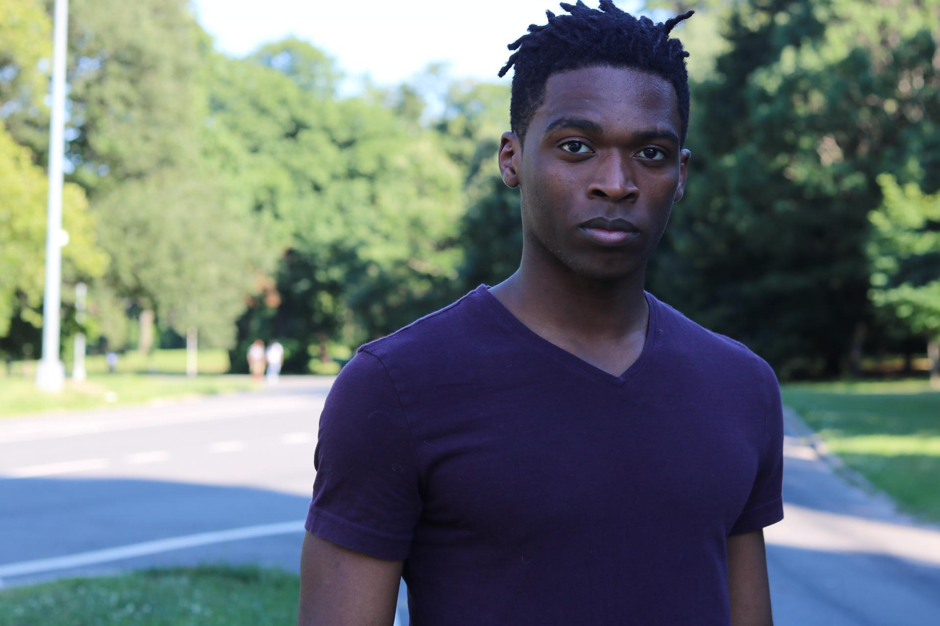Frantz Theodore

Omni.Frantzce@gmail.com

(347) 634-7295

Height: 5’10 Hair Color: Black Eye Color: Dark Brown

**Film:**

Role Project Director

Dancer/Student Big Dogs Tony Glazer

Kevin (Thug) Bronx SIU Mike Mayhall

Freddy The Fatalist Nicolas Mones

Patrick Friend-versary Camila Grimaldi

**Theatre:**

Role Project Space

Tom Fat Pig NYCDA

Floyd Barton Seven Guitars NYCDA

**Special Skills:**

Parkour

Driver’s license

Skateboarding

Bike Riding

Euphonium player

Trombonist

Dance (hip hop)

**Training:**

New York Conservatory for the Dramatic Arts (School of film and television) August 2015- May 2017

Brooklyn Zoo 2016-current (Stunts and parkour training)

Acting for Camera Alan Rackham & Rawleigh Moreland

Scene study for Film & Television Kevin Breznahan and Becky London

Meisner Steve Perlmutter

Viewpoints Donnie Mather

Actor Comedy Workshop Judith Searcy

Audition Techniques Neal Lerner

Acting in commercial / Voice-over Lane Binkley